

University of Sialkot

Semester Project – Deliverable 1 (Client-Side Architecture)

STUDENT ROLL NUMBER: 23010101-102, 23010101-048
STUDENT NAME: Ayesha Usman, Asiya Farooq
TOTAL GRADE POINT 10
GRADE POINT ALLOCATED

Instructor: Museb Khalid

Contents

Semester Project – Deliverable 1 (Client-Side Architecture) 1
Instructor: Museb Khalid 1
1. Introduction 3
2. Project Overview 3
3. Objectives 3
4. Technologies Used 3
5. Project Folder Structure 4
Folder Explanation 4
6. Single Page Application (SPA) 4
7. Vue Router Implementation 5
Features of Vue Router 5
Router Structure 5
8. Pages Description 6
8.1 Home Page 6
Functions 6
8.2 Register Page 6
Functions 6
8.3 Participants Page 6
Functions 7
8.4 History Page 7
Functions 7
9. Component Architecture 7
Advantages 7
10. Architecture Tree 7
11. Inter-Component Communication (Props & Emits) 8
Props 8
Emits 8
Benefits of Props and Emits 9
12. Code Snippets 9
App.vue 9
main.js 9
Navigation Example 9
13. Screenshots 9
Figure 1: Home Page 10
Figure 2: Register Page 10
Figure 3: Participants Page 10
Figure 4: History Page 10
14. Project Evaluation 10
15. Future Enhancements 11
16. Conclusion 12
17. IEEE References 12

1. Introduction
The Expense Splitter Web Application is developed using Vue 3 and Vite. The purpose of this application is to simplify expense management among multiple participants. Instead of manually calculating individual shares, the system allows users to register participants, manage expenses, and view expense history through a modern web interface.
The application follows the Single Page Application (SPA) architecture where page navigation occurs without refreshing the browser. Vue Router is used for routing, while reusable Vue components improve maintainability and scalability. The project demonstrates modern frontend development practices using Vue 3.

2. Project Overview
The Expense Splitter application provides an easy way to divide expenses among different participants. Users can navigate through multiple pages including Home, Register, Participants, and History.
The project is implemented using Vue 3 with Vite for fast development and Vue Router for navigation. The application follows a modular component-based architecture where each page is created as an independent Vue component.

3. Objectives
The main objectives of the project are:
- Develop a Single Page Application using Vue 3.
- Implement Vue Router for seamless navigation.
- Create reusable Vue components.
- Provide a clean and responsive user interface.
- Organize project files using proper folder structure.
- Demonstrate modern frontend development practices.
- Prepare the frontend architecture for future backend integration.

4. Technologies Used
Technology | Purpose
Vue 3 | Frontend Framework
Vite | Build Tool
Vue Router | Page Navigation
JavaScript | Application Logic
HTML5 | Structure
CSS3 | Styling

5. Project Folder Structure
src
│
├── assets
└── main.css
└── base.css
├── components
├── router
│ └── index.js
├── views
│ ├── Home.vue
│ ├── Register.vue
│ ├── Participants.vue
│ └── History.vue
│
├── App.vue
└── main.js

Folder Explanation
assets
Stores images, icons, and static resources used throughout the application.
components
Contains reusable Vue components that can be used across different pages.
router
Contains the router configuration responsible for navigation between different views.
views
Contains the main pages of the application such as Home, Register, Participants, and History.
App.vue
Acts as the root component of the application and loads RouterView.
main.js
Initializes Vue application and mounts it to the browser.

6. Single Page Application (SPA)
The project follows the Single Page Application (SPA) concept. Instead of loading a new webpage every time the user navigates, Vue Router dynamically replaces the content displayed inside the RouterView component.
This approach provides:
- Faster navigation
- Better user experience
- Reduced page loading time
- Efficient component reuse

7. Vue Router Implementation
The Expense Splitter application uses Vue Router to implement Single Page Application (SPA) navigation. Vue Router allows users to move between different pages without refreshing the browser. Instead of loading separate HTML files, Vue dynamically replaces the content inside the <RouterView> component.
The router configuration defines different routes for each page of the application. Each route is mapped to its corresponding Vue component stored inside the views folder.

Features of Vue Router
- Smooth page navigation
- No full page refresh
- Better user experience
- Organized routing structure
- Easy scalability for future pages

Router Structure
import { createRouter, createWebHistory } from 'vue-router'
import Home from '../views/Home.vue'
import Register from '../views/Register.vue'
import Participants from '../views/Participants.vue'
import History from '../views/History.vue'
const routes = [
{
path:'/',
component:Home
},
{
path:'/register',
component:Register
},
{
path:'/participants',
component:Participants
},
{
path:'/history',
component:History
}
]
const router = createRouter({
history:createWebHistory(),
routes
})
export default router
The above router configuration registers all application pages and enables seamless navigation throughout the project.

8. Pages Description

8.1 Home Page
The Home page serves as the landing page of the Expense Splitter application. It provides an introduction to the system and acts as the starting point for users. Navigation links allow users to access other sections of the application.

Functions
- Displays project title
- Welcomes users
- Provides navigation to other pages
- Improves user experience through a clean interface

8.2 Register Page
The Register page allows users to enter their information before using the application. This page contains a registration form where user details can be added.

Functions
- User registration
- Input validation
- Form submission
- Easy user management

8.3 Participants Page
The Participants page is responsible for displaying and managing participants involved in expense sharing.

Functions
- Add participants
- Display participant list
- Update participant information
- Remove participants if necessary
This page improves organization by keeping all participant information in one location.

8.4 History Page
The History page displays previously recorded expense information. It helps users review past transactions and keeps expense records organized.

Functions
- View previous expenses
- Display expense history
- Improve transparency
- Easy record management

9. Component Architecture
Vue follows a component-based architecture. Instead of writing all code inside a single file, the project is divided into multiple reusable components.

Advantages
- Code reusability
- Easy maintenance
- Better readability
- Improved scalability
- Faster development
Each Vue file represents a separate component responsible for a specific functionality.

10. Architecture Tree

Expense Splitter
│
├── App.vue
├── main.js
│
├── assets
│ ├── base.css
│ └── main.css
│
├── components
│
├── router
│ └── index.js
│
└── views
├── Home.vue
├── Register.vue
├── Participants.vue
└── History.vue

The architecture shows that App.vue is the root component. Navigation is handled through Vue Router, while each page is stored separately inside the Views folder.

11. Inter-Component Communication (Props & Emits)
Vue provides Props and Emits for communication between components.

Props
Props transfer data from a parent component to a child component.
Example:
<ParticipantCard
name="Ali"
amount="500"
/>
The child component receives these values through props.
Example:
defineProps({
name:String,
amount:Number
})

Emits
Emits allow child components to send information back to the parent component.
Example:
const emit = defineEmits(['deleteParticipant'])
emit('deleteParticipant', participant.id)
The parent component receives the emitted event and performs the required action.

Benefits of Props and Emits
- Clean communication
- Better component independence
- Reusable components
- Organized application structure

12. Code Snippets

App.vue
<template>
<RouterView />
</template>
This component loads the currently active page based on the selected route.

main.js
import { createApp } from 'vue'
import App from './App.vue'
import router from './router'
createApp(App)
.use(router)
.mount('#app')
This file initializes the Vue application and registers Vue Router.

Navigation Example
<RouterLink to="/">Home</RouterLink>
<RouterLink to="/register">Register</RouterLink>
<RouterLink to="/participants">Participants</RouterLink>
<RouterLink to="/history">History</RouterLink>
RouterLink enables navigation between pages without reloading the browser.

13. Screenshots
According to the assignment requirements, screenshots should be included as proof that the application is running successfully on localhost. The following screenshots should be captured after running the Vue application.

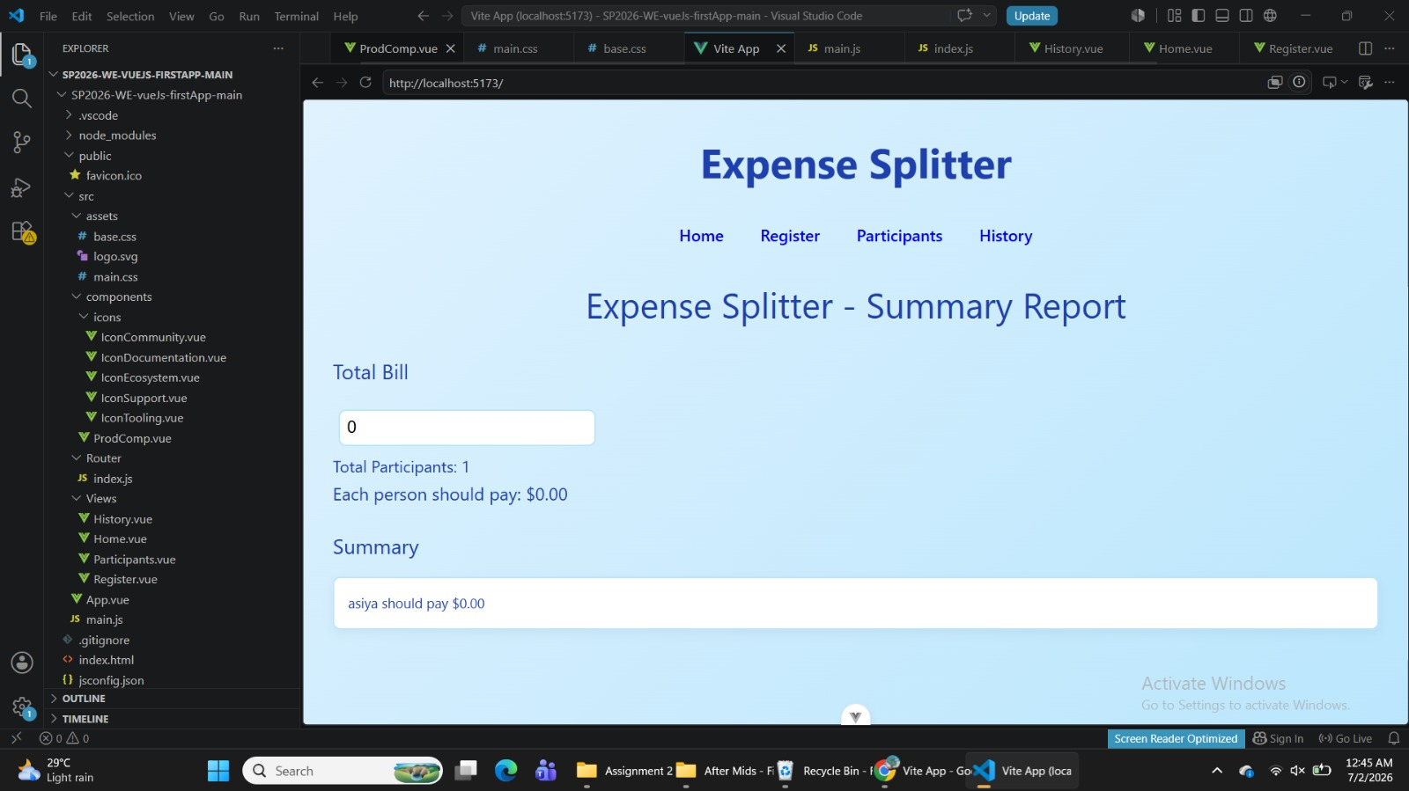

Figure 1: Home Page
Description
Home Page: Total bill input aur per person share calculation
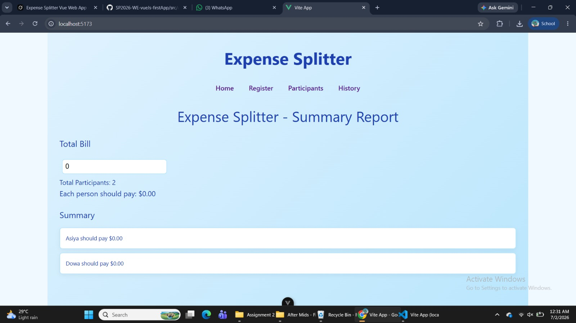

Figure 2: Register Page
Description
Register Page: New participant registration form
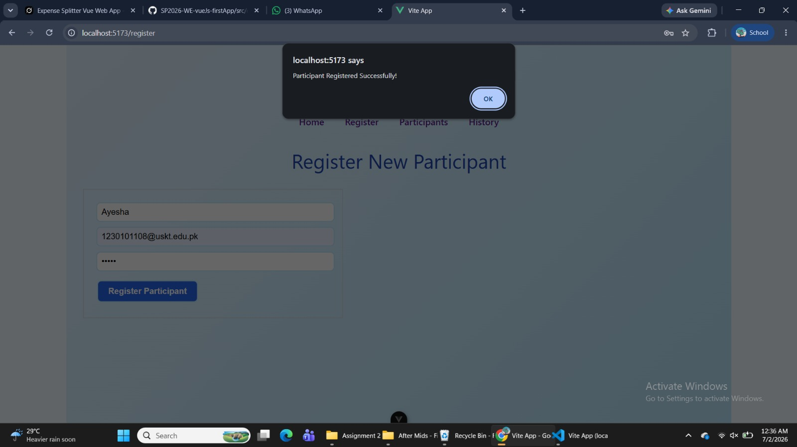

Figure 3: Participants Page
Description
Participants Page: List of participants with remove functionality

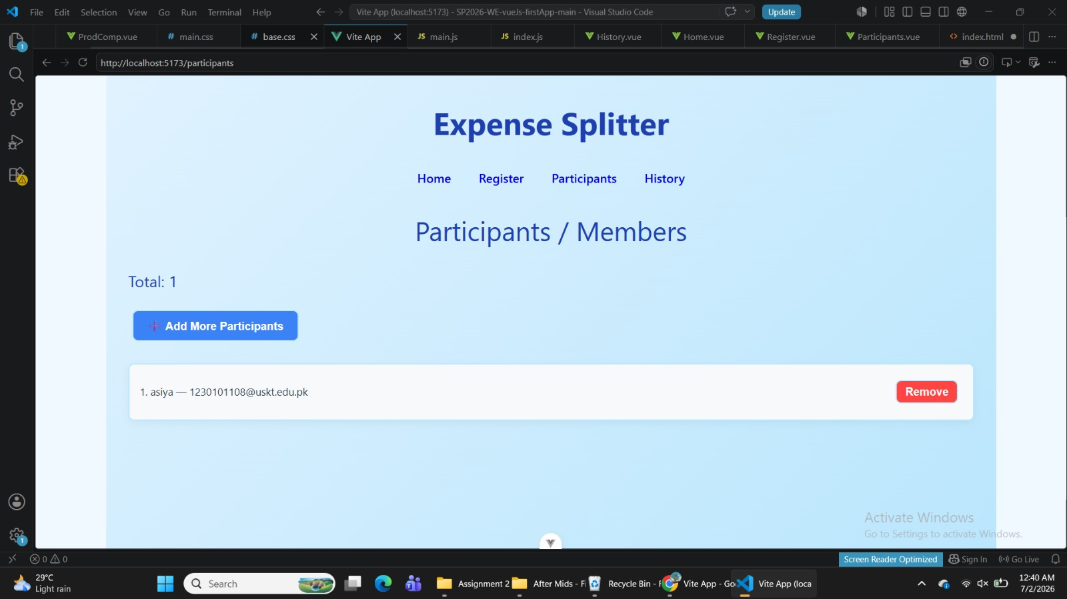

Figure 4: History Page
Description
History Page: Previous expense split records

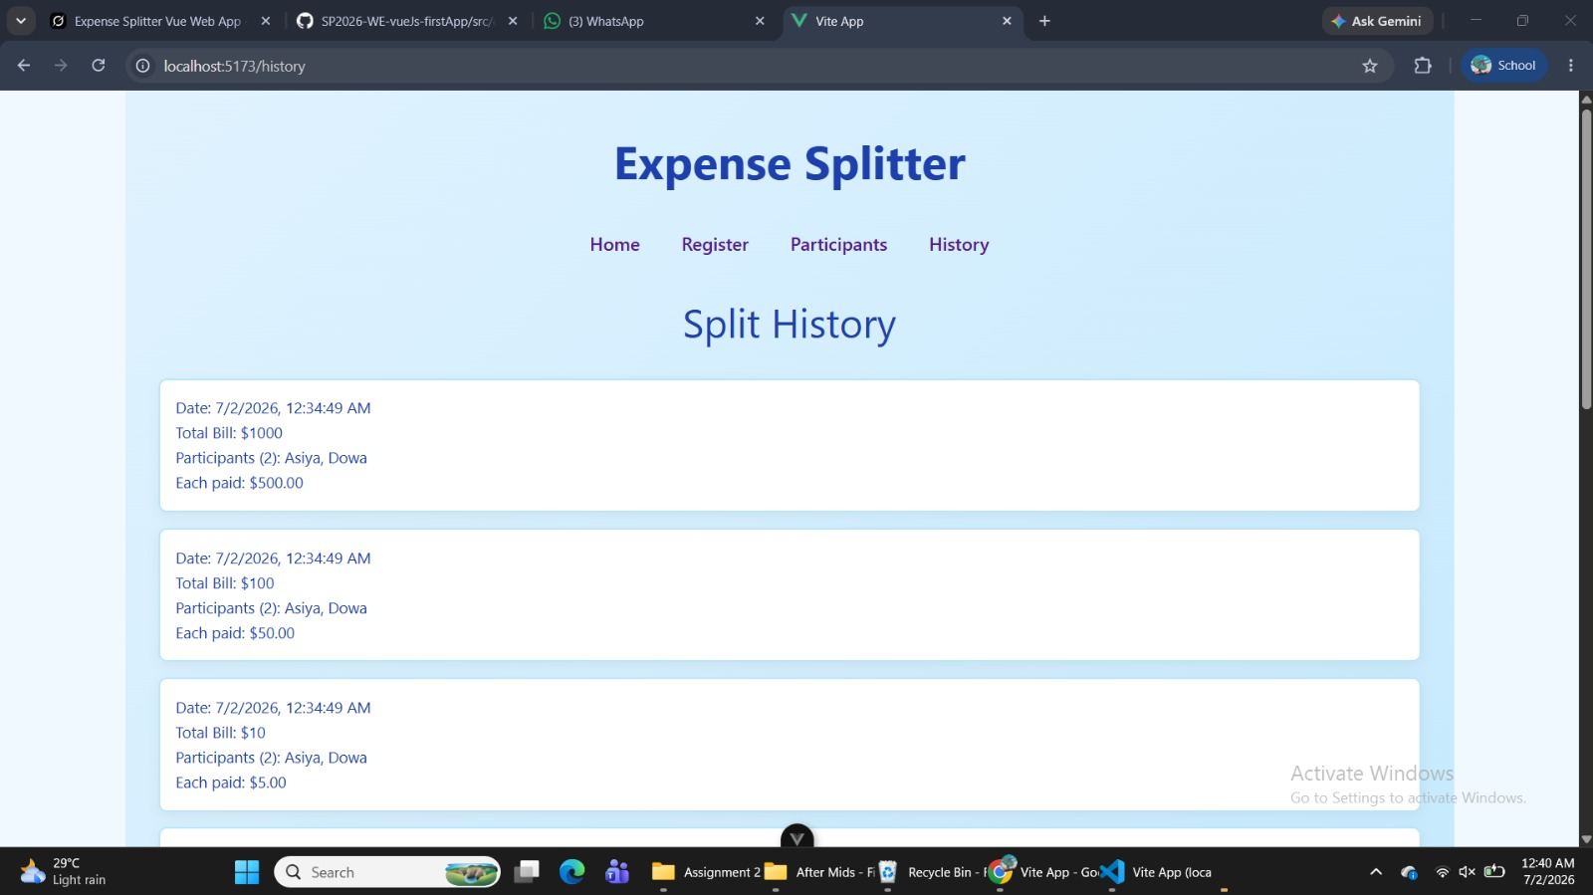

14. Project Evaluation
The Expense Splitter application successfully demonstrates the client-side architecture required in the project specification. The application is developed using Vue 3 and follows the Single Page Application (SPA) model. Vue Router enables smooth navigation between pages without requiring full page reloads.
The project adopts a modular structure where every page is implemented as an independent Vue component. This organization improves readability, maintainability, and scalability of the application. The folder structure is clean and follows Vue development standards, making future enhancements easier.
The application currently includes the following main pages:
- Home
- Register
- Participants
- History
Each page has a specific responsibility, reducing code duplication and improving software quality.
The use of Vue Router ensures seamless navigation while Vite provides fast development and efficient project building.
Overall, the project satisfies the primary frontend architecture requirements outlined in the assignment.

15. Future Enhancements
Although the current deliverable focuses only on the frontend, several improvements can be added during future development phases.
Future enhancements include:
- Integration with Express.js backend.
- MongoDB database connectivity.
- User authentication and authorization.
- Secure login and registration.
- Expense editing and deletion.
- User profile management.
- Dashboard with expense statistics.
- Graphical reports and charts.
- Search and filtering functionality.
- Responsive mobile-friendly interface.
- Dark mode support.
- Notification system.
- Export expense reports to PDF.
- Real-time synchronization of expense data.
These enhancements will transform the application into a complete full-stack expense management system.

16. Conclusion
The Expense Splitter Web Application successfully implements the client-side architecture using Vue 3 and Vite. The project follows the Single Page Application (SPA) architecture, enabling efficient navigation through Vue Router without refreshing the browser.
The application's modular component structure promotes code reusability and simplifies maintenance. Individual pages such as Home, Register, Participants, and History are separated into dedicated Vue components, making the project easier to understand and extend.
The selected technologies provide excellent performance, fast development, and scalability. Vite significantly reduces build time while Vue Router ensures smooth user navigation throughout the application.
The project demonstrates modern frontend development practices and provides a strong foundation for future backend integration using Express.js and MongoDB. Overall, the implemented architecture fulfills the client-side objectives of the semester project and aligns with the assignment requirements.

17. IEEE References
[1] Vue.js Team, "Vue.js Documentation." [Online]. Available: https://vuejs.org/.

[2] Vue.js Team, "Vue Router Documentation." [Online]. Available: https://router.vuejs.org/.

[3] Vite Team, "Vite Documentation." [Online]. Available: https://vite.dev/.

[4] Mozilla Developer Network (MDN), "JavaScript Guide." [Online]. Available: https://developer.mozilla.org/en-US/docs/Web/JavaScript.

[5] Mozilla Developer Network (MDN), "HTML: Hypertext Markup Language." [Online]. Available: https://developer.mozilla.org/en-US/docs/Web/HTML.

